- \Operation\Hot air station\Hot air station
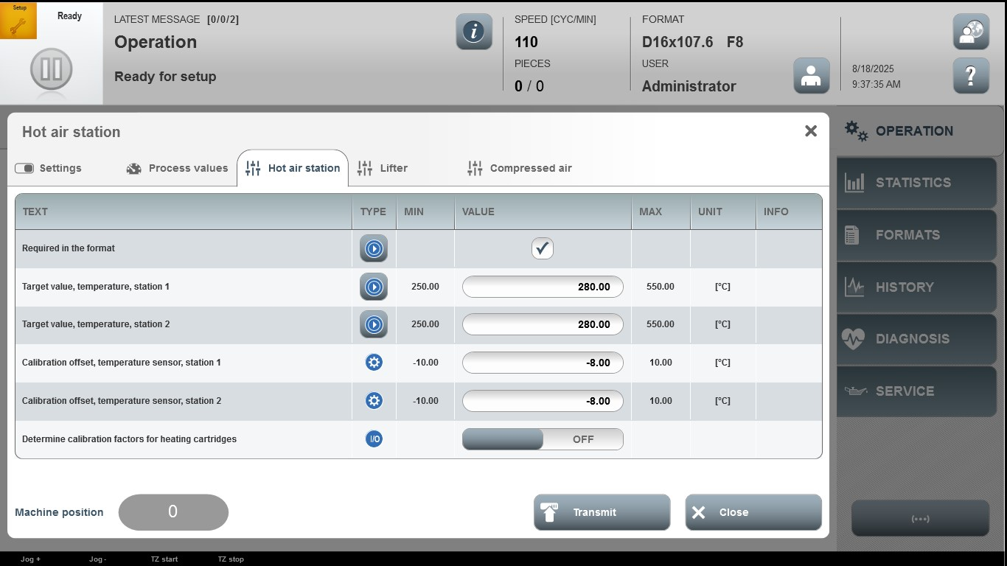

Acceptance criterion | Limits | Pass / Fail: Dev-No. | Date | Initials
Screen matches screenshot | N / A
Target value, temperature, station 1 | 250.00 … 550.00
Target value, temperature, station 1 | 250.00 … 550.00
Calibration offset, temperature sensor, station 2 | -10.00…10.00
Calibration offset, temperature sensor, station 2 | -10.00…10.00

